**Contents**



**PaaS DevOps Engineer**

1. Company Profile 3

2. Our Brand 5

3. Role Profile 6

4. Candidate Profile 6

# Company Profile

*Experian is a leading global information services company that unlocks the power of data to create opportunities for consumers, businesses and societies across the world.*

*During life’s big moments – from buying a home or car, to sending a child to college, to growing a business exponentially by connecting it with new customers – we empower consumers and our clients to manage their data with confidence so they can maximize every opportunity.*

*We gather, analyse and process data in ways others can’t. We help individuals take financial control and access financial services, businesses make smarter decisions and thrive, lenders lend more responsibly, and organizations prevent identity fraud and crime.*

*For more than 125 years, we’ve helped consumers and clients prosper, and economies and communities flourish – and we’re not done.*

*Our 17,000 people in 40 countries believe the possibilities for you, and our world, are growing. We’re investing in new technologies, talented people and innovation so we can help create a better tomorrow.*

**What we do**

We aim to place clients and consumers at the heart of everything we do. We help them to make the most of their data and realise their ambitions by enabling quicker, smarter decisions using our analytics and software.

The breadth, depth and accuracy of data, combined with analytics, help to drive informed and trusted decisions for our clients. We hold and manage powerful data sets, including credit data on 989 million people and 111 million businesses.

The data we hold varies, for example from how you have repaid credit in the past, to whether a car has been in an accident, to your eligibility for healthcare services in the USA, to how you like to respond to online advertising. Our industry experts collaborate with our data analysts and scientists to create innovative analytics and software to help solve our clients’ challenges.

We help millions of consumers to:

* better access financial services;
* understand and improve their financial position;
* protect their identity; and
* know that their data is correct.

We help thousands of businesses and organisations to:

* manage credit risk;
* prevent fraud;
* better understand their customers; and
* better understand their markets and allocate resources.

Our clients come from a wide variety of areas, including financial services (33%), consumers (19%), healthcare (7%), retail (5%), telecoms and utilities (5%), automotive (5%), insurance (4%), media/technology (3%) and government and public sector (2%).

We provide services in North America, Latin America, UK and Ireland and EMEA/Asia Pacific, and we manage and report our performance across those regions. North America accounts for the largest proportion of revenues (56%), while Latin America accounts for 17%, UK and Ireland for 19%, and EMEA/Asia Pacific for 8%.

We employ more than 17,000 people across 40 countries. Our corporate headquarters are located in Dublin, Ireland, with operational headquarters in Nottingham, UK; California, USA; and São Paulo, Brazil. We are listed on the London Stock Exchange and are a constituent of the FTSE 100 index. Market capitalisation was approximately £16bn as at May 2017 and, for the past five years, Experian has been named by *Forbes* magazine as one of the 'World's Most Innovative Companies'.

**Our business activities**

Our business activities in our regions are grouped into the following four areas:

**Credit Services (55% of revenues):** We help organisations lend responsibly and protect themselves and their customers from risk. From our 17 consumer and 11 business information bureaux, we provide millions of credit reports every day, enabling lending decisions to be made fairly, responsibly and quickly for people and businesses**.**

**Decision Analytics (13% of revenues):** We help our customers to lend effectively and to minimise the risk of fraud by developing advanced software and models to analyse data.

**Marketing Services (10% of revenues):** We help businesses to understand their customers. We use our strengths in data management and analytics to give our clients a clear picture of who each individual is and of their needs, so they can target relevant offers and communications to each individual.

**Consumer Services (22% of revenues):** We empower people to take control of their credit – helping them to understand and better manage their financial position, while protecting themselves from identity theft and fraud.

**Our strategy**

Our strategy is focused on delivering a significant growth agenda supported by several foundational principles:

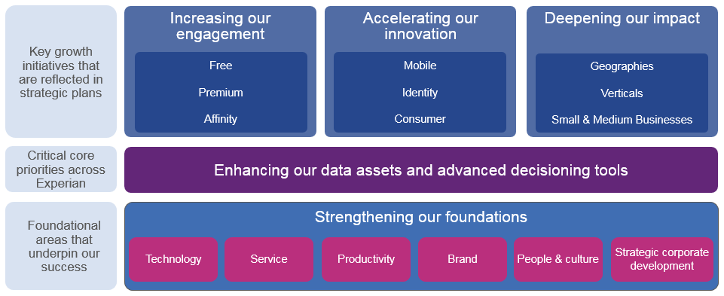

# Our Brand

Our brand brings to life our strategy of putting clients and consumers at the heart of everything, being more collaborative through a ‘One Experian’ approach and even more innovative. It embodies a clear ambition for us to help people and businesses create a better future for themselves.

Our core beliefs are:

1. Data is central to how we all live. It has the potential to transform all our lives for the better.
2. We can unlock the power of data to realise opportunities for people and organisations.
3. It is how we can help that sets us apart. We place the power of data and our expertise in the hands of our customers, creating opportunities and helping them plan for a better future with confidence.
4. That we can make a difference to society and our communities, by helping people make the most of their data
5. That how we work is as important as what we do: we treat everyone fairly and their data with respect; we work with integrity, always.

**How we work is as important as what we do**

Success at Experian is evaluated based on performance, what we do – our objectives – and how we do it – our behaviours and capabilities. We’ve recently developed and launched ‘The Experian Way’ - a unique and consistent way of working globally. It informs how our people act and behave, which shapes our culture. It’s defined across five key areas of strategic importance:

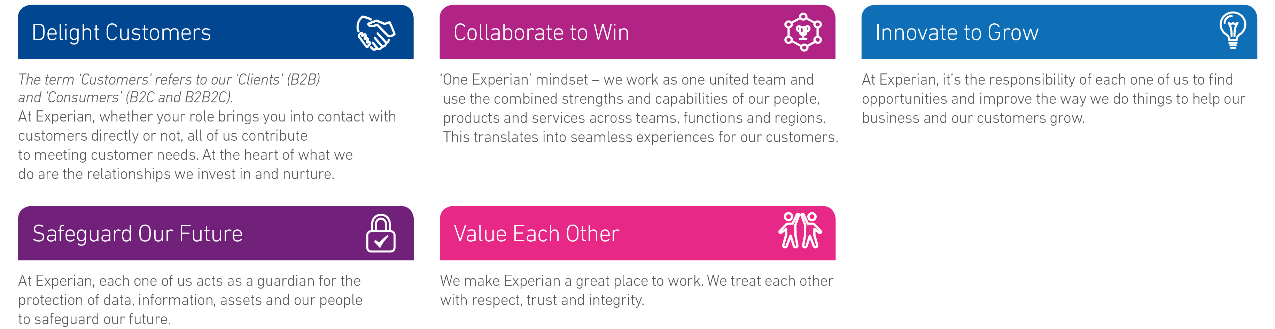

Value each other

# Role Profile

**Role Summary**

**\*\*ACTION NEEDED\*\***

**Job purpose**

**\*\*ACTION NEEDED\*\***

**Key Responsibilities**

* Support the deployment and operation of Experian’s strategic PaaS facility, based on Openshift Container Platform
* Assist in troubleshooting/remediation and pro-active maintenance of all hardware and software elements that combine to deliver the platform
* Ensure that all work carried out complies with global standards and contribute to the development of those standards, to enable ongoing fit-for-purpose
* The engineer will work closely to design and build automated operational processes focusing on scalable deployments to PaaS Evn.
* Assist developers in using the in-house docker registry to create/publish applications with strong emphasis on collaboration and communication
* Work as part of PaaS DevOps Engineer team to establish and support an automated CI/CD process using Jenkins, Artifactory and Openshift container platform   
  Engaged in 24/7 Production support of globally deployed solutions both On-prem and in the Cloud
* Support a multi-tenant container configuration – to global standards
* Assist client support teams to ensure issues are dealt with in a professional and timely manner
* Build/Support Non-Prod (Dev, Test, Staging) and Production container platform environments
* Standardize, build, and support a portfolio of reusable components, services and interfaces
* Ensure the availability, performance, reliability, and reporting of global container platform environments
* Improve productivity in delivery orchestration, proactive monitoring, self-healing automation and operation validations
* Collaborate and coach internal business unit team members to help build container ready applications using standard automated CI/CD processes
* Work as part of both the APAC regional team, as well as the global application development and platform architecture teams

# Candidate Profile

**Skills & Experience**

* Experience with…
  + Linux (RHEL)
  + Docker
  + Kubernetes – preferably Red Hat OpenShift
  + Java (JVM-based applications)
  + TCP Networking
  + Amazon Web Services
  + Azure
  + Ansible
  + Jenkins
  + Bitbucket
  + Container Registry
  + Gluster File System
* Strong scripting or programming background.
* Experience with and understanding of multi-tier web application architectures.
* Strong communication skills and ability to work in a globally distributed team.
* Good operational skills with Linux, Networking, DNS and SSL.

**Qualifications**

* Preferred: Master’s degree (or foreign equivalent) in Computer Science, Electronics and Communication, or Engineering.
* 5+ years of experience in Software Engineering comprising of designing, developing and operating robust and highly-scalable PaaS infrastructure services.
* Experience on support microservices architecture.
* Experience working on elastic and data intensive applications.